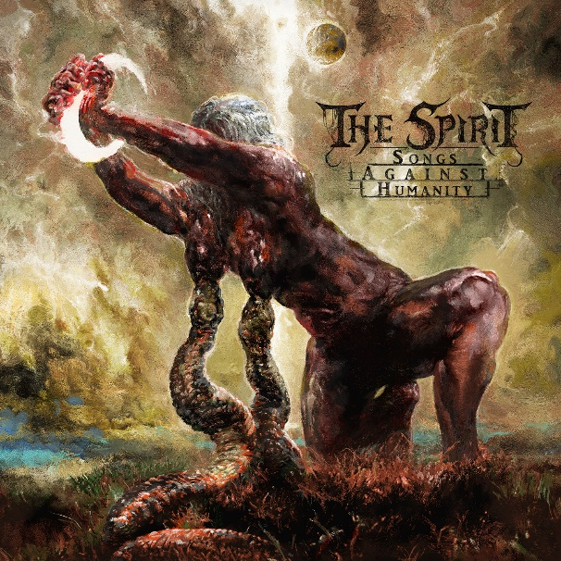**THE SPIRIT**

**Songs Against Humanity**

**AOP Records**

**Release date: October 25th, 2024**

**Black/Death Metal**

**Line-Up:**  
Matthias Trautes – vocals, guitars, bass  
Manuel Steitz – drums

[www.facebook.com/thespiritband](http://www.facebook.com/thespiritband)

[www.instagram.com/thespirit_band](http://www.instagram.com/thespirit_band)

<https://linktr.ee/thespiritband>

**THE SPIRIT** remain loyal to their policy to release every two years a new album. After their third offering **“Of Clarity and Galactic Structures”** from 2022 where the band hit a new high in terms of song complexity and depth, the new output **“Songs Against Humanity”** goes again into another direction. Despite containing the two longest tracks in the bands career, the songs on the new record are way more straight forward and catchy as fuck.

*“I started in January 2023 with the songwriting”* composer **Matthias Trautes** says. *“The first song I wrote was “Death is my Salvation”. And you can clearly hear that I was still a bit in the mood of the ”Of Clarity and Galactic Structures” record. Using odd time signatures and giving the music more depth.”*But why the record turned out to become more “basic” than its predecessor, the prog rock enthusiast explains.

*“Unfortunately, things in my life didn’t go well for a while and in 2023 everything got even more fucked up and that year was about to become the worst year ever for me. When I hit rock bottom and thought it couldn’t get worse, life showed me it can always go further down. I got serious health issues and spent months in the worst pain I ever had to endure. Going through this had a big impact on how I think about my life and the world in general. With a lot of work, perseverance and the will to get better, I managed to fight my way out of this suffering and I could finally continue with the songwriting at the end of 2023. I was grateful for every day I woke up without pain, but my mind had changed in the last 10 months, and I didn’t feel the need anymore to experiment with odd time signatures or write complex music to challenge me. I was pissed and furious and I released that energy and anger into the new songs. That’s way they turned out to be more powerful and straight forward compared to the previous record.”*

Like the last two records the new album has been recorded once again at **Woodshed Studio, Germany,** engineered by **V. Santura** and drums being tracked at **Iguana Studios** by **Christoph Brandes.** **THE SPIRIT’s** lyrics consist on one side of misanthropic views on the world and on the other side of cosmic themes that carry the listener deep into the vast of the universe. **“Matthias Trautes”** never withheld his opinion about humanity on any album. But as the title **“Songs Against Humanity”** speaks for itself, on this record he immerged deeper into this topic than ever before.

**V. Santura** wasn’t only involved as an engineer. This time the Triptykon and Dark Fortress guitarist also contributed to the album with his 6-string skills and recorded the solo in “Death is my Salvation”.

*“Victor is a good friend of mine and a very good guitarist. I was quite happy when he agreed to write a solo for this song. And damn, he nailed it. Maybe that’s the reason it’s my favourite song on the album.*

*And when we talk about Victor. The first time I realised this could probably be our strongest record to date is when he called me the day he finished the master and said on the phone “I just want to tell you that this record is super strong, it only contains hits“. I know him and he doesn’t say such things just like that. So that was a huge compliment.*

The cover artwork was painted by internationally renowned artist **Eliran Kantor**. The band worked already for the second time with the Berlin based artist.

**Tracklist**  
1. Against Humanity  
2. Room 101  
3. Cosmic Rain and Human Dust  
4. Spectres of Terror  
5. Death is my Salvation  
6. Nothingness Forever  
7. Orbiting Sol IV

The Horror in Human Form (bonus track lim. trifold vinyl)

**Credits**

All music and lyrics written by Matthias Trautes

Guitar solo in “Death is my Salvation” by V. Santura.

Drums recorded at Iguana Studio, Germany, and engineered by Christoph Brandes.

Guitars, bass and vocals recorded at Woodshed Studio, Germany and engineered by V. Santura.

Mixed and mastered by V. Santura

Artwork painted by Eliran Kantor

Photos by Anne Catherine Swallow