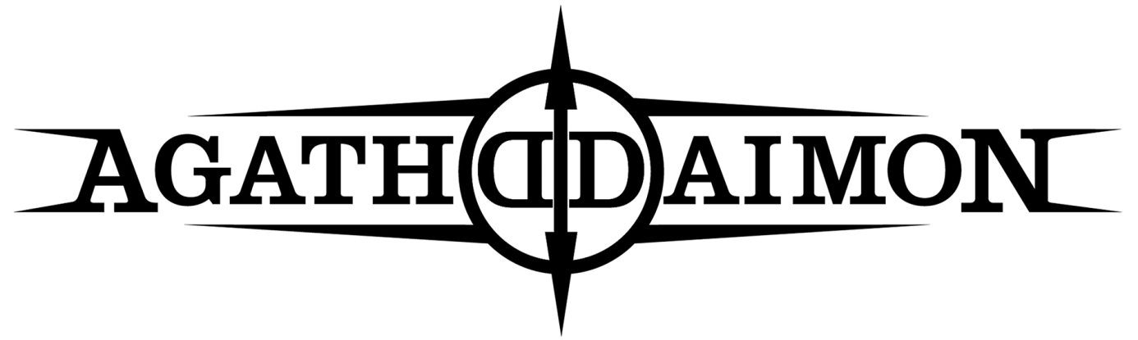  
Agathodaimon was formed in September 1995 by Sathonys (guitar) and Matthias Rodig (drums). After placing some ads in several music magazines, they soon found the right band mates in Vlad (vocals, keys), Hyperion (guitar) and Marko T. (bass).   
  
Together, a first demo was recorded in April 1996, entitled CARPE NOCTEM, which led to the first excellent reviews, so Agathodaimon recorded the second demo NEAR DARK in 1997 which received excellent response from the metal scene, resulting in a deal with Nuclear Blast. A debut album was scheduled for early 1998, but had to be delayed after Romanian vocalist Vlad was denied return to Germany by the authorities after a short trip to Bucharest. Multiple attempts failed to get him back, and so the recordings were finally done with the help of vocalist Akaias.   
  
BLACKEN THE ANGEL was released in late 1998.   
Gigs and tours with bands such as Benediction and Hypocrisy followed, as well as   
some festival appearances at Wacken Open Air or Wave Gotik Treffen.  
The keyboard slot was temporarily filled by Marcel Traumschänder of Nocte Obducta, as at that time, both Sathonys and Matthias were also playing in Nocte Obducta. Sathonys left in 1999 though, to concentrate on Agathodaimon. A tour with Dismember and Children of Bodom followed, and shortly after, new keyboard player was found in Christine, so the band prepared for their second album HIGHER ART OF REBELLION. To avoid further troubles with Vlad's immigration, the whole band instead travelled to Bucharest to record the second album all together.

Experimenting with new influences outside Black Metal, the songs were partly progressive, melodic, yet keeping a dark and sinister vibe. A few months later, it became obvious that what once was meant as interim solution turned into a steady cooperation:   
Akaias officially became the permanent singer of Agathodaimon,   
while Vlad decided to leave the band. But first, a headliner tour with Siebenbürgen and Graveworm followed in 2000, and the songwriting for the third album began.

This time, the band wanted to mix both the progressive and melodic elements with the raw and straight attitude from the debut album. CHAPTER III marked another important step, and festival appearances at Wacken, Wave Gotik Treffen and Summer Breeze were done.  
  
In 2001, CHAPTER III was released. Later on, some line-up changes happened: Bass player Marko, guitarist Hyperion and also Christine left the band. Vocalist Akaias decided to take over the guitar, being used to handle both vocals and guitar with his other band Asaru. A new keyboard player was soon found in Felix, and some months later, bass player Eddie joined the band.   
  
A lot of rehearsals and some gigs in countries such as Slovakia, Slovenia and Austria were done to get in shape, plus some smaller tours with bands such as Enthroned and Cradle of Filth, before the work on SERPENTS EMBRACE began in late 2003.

The album was released in 2004 and had the highest production values so far:   
Rich songs, featuring a wide range of styles, from old black metal roots to electronic sounds, melodic and balladic tunes, groovy, partly fast, partly doom-inspired, delivering the essence of all stylistic adventures Agathodaimon went through the years before.   
An exclusive song was written later on for the movie soundtrack of "Alone In The Dark".

The years 2005 and 2006 saw a lot of gigs; in 2006 bass player Till replaced Eddie. By the end of 2006, vocalist/guitarist Akaias decided to permanently move to Norway, therefore some replacements had to be found- Jonas (vocals) and Jan (guitars) joined Agathodaimon.

Due to lack of time, founding member Matthias and also Jonas had to leave the band in 2008, which led to further delays concerning the work on the next album. Replacements were found in Manuel Steitz (drums) and Ashtrael (vocals).  
  
Recordings for the fifth album, entitled PHOENIX, took again place at Kohlekeller studio. The album was released in march 2009. Many concerts and festivals (like Brutal Assault or Wacken Rocks) followed to support the album.  
  
During the work on the successor of PHOENIX, Jan left due to musical differences and Thilo Feucht, who did contribute both to studio recordings since Chapter III and several live gigs as session musician, joined the band. A tour with Graveworm was next, before IN DARKNESS was released in 2013.

Followed by selected gigs with Atrocity and a short visit to Romania and Bulgaria, Sathonys then officially put the band on ice for personal reasons, in order to focus on his family.

But it was not meant to be the end- although Till and Thilo left the metal scene meanwhile, Sathonys and Ashtrael began actively working on a new line up in late 2018, and found replacements in Von Yanesh (bass) and Mortos (drums), as former drummer Manuel meanwhile was fully occupied with his other band The Spirit.   
  
Having found a new home at Napalm Records in 2020, the release of their comeback album THE SEVEN was delayed thanks to Covid19 outbreak, but finally released in March 2022.  
  
Discography:   
  
Carpe Noctem (demo) - 1996  
Near Dark (demo) - 1997  
Blacken The Angel - 1998  
Higher Art Of Rebellion - 1999  
Chapter III - 2001  
Serpent's Embrace - 2004  
Phoenix - 2009  
In Darkness – 2013  
The Seven - 2022  
  
Line-Up:  
  
Frankior – vocals  
Sathonys – guitars, clean vocals  
Moerk – guitars  
Von Yanesh – bass  
Mortos - drums